**“MENTAL HEALTH DETECTION USING MACHINE LEARNING”**

KAJAL NIKAM, ROHINI DAWANGE, VAIBHAV WALKE, KARAN DABHADE

MATOSHRI COLLEGE OF ENGINEERING AND RESEARCH CENTER

----------------------------------------------------------------------***-------------------------------------------------------------------

**Abstract -** Mental health is a crucial aspect of overall well-being, and its early detection and intervention play a pivotal role in preventing severe mental health issues. This system presents an innovative approach to mental health detection using machine learning (ML) techniques. The system categorizes users into three levels: low, medium, and high, based on their mental health status, allowing for personalized recommendations to improve their mental state. To assess the users' mental health levels, the system employs a carefully designed set of multiple-choice questions, which effectively gauge various aspects of their emotional and psychological well-being. These questions consider factors such as mood, stress levels, sleep patterns, and social interactions to provide a comprehensive evaluation. Upon categorization, users receive tailored suggestions and resources to address their specific mental health needs, thereby promoting a proactive and personalized approach to mental health care. This ML-based mental health detection system has the potential to make a significant impact by identifying mental health issues early and guiding individuals towards the necessary support and resources to enhance their well-being.

**Keywords:** Mental, Machine learning, Suggestions

**INTRODUCTION**

Mental health is an integral component of an individual's overall health and quality of life. Detecting and addressing mental health concerns at an early stage can significantly improve well-being and prevent the progression of more severe mental health conditions. In recent years, machine learning (ML) has emerged as a powerful tool for various applications, including healthcare. This paper introduces a novel approach to mental health detection using ML techniques, aiming to categorize users into three levels: low, medium, and high, based on their mental health status. By employing a carefully crafted set of multiple-choice questions that delve into various aspects of emotional and psychological well-being, this system seeks to provide a holistic assessment of an individual's mental health. Once categorized, users will receive personalized recommendations and resources tailored to their specific mental health needs, fostering a proactive and individualized approach to mental health care. This innovative system holds great promise in identifying mental health issues early, ultimately leading to more effective interventions and improved mental well-being for individuals across diverse backgrounds.

In recent years, the importance of mental health awareness and support has gained significant recognition worldwide. However, there remains a considerable gap in early detection and personalized intervention strategies for individuals struggling with mental health challenges. Traditional methods often rely on self-assessment or professional diagnosis, which can be time-consuming, stigmatizing, or simply unavailable to many. Machine learning offers a revolutionary approach by providing an objective and scalable means to assess mental health levels based on user responses to carefully designed questions. By automating this process, individuals can gain quicker access to resources and recommendations tailored to their specific mental health needs, reducing the burden on healthcare systems and improving the overall well-being of individuals in need. This paper explores the potential of ML-based mental health detection, shedding light on a promising avenue for proactive and personalized mental health care that holds the promise of positively impacting countless lives.

**LITERATURE SURVEY**

The literature survey comprises four distinct studies focusing on various aspects of mental health and its management. The first study by Kazi Zawad Arefin explores the development of an Electronic Medical Record (EMR) system for children's mental health in underserved communities in the USA. This innovative system reduces paperwork and storage burdens, facilitating the screening and intervention processes for ASD children, even during the COVID-19 pandemic. [1].

The second study by Braden Tabisula emphasizes the need for an adaptive sociotechnical model for managing mental health during a pandemic. It underscores the diversity of technologies available for addressing mental health distress and proposes a sociotechnical model to assess their effectiveness. [ 2].

The third study by Jinping Liu delves into the impact of innovation and entrepreneurship education on the mental health of medical students, providing insights into strategies for enhancing their well-being [3].

Lastly, Muhammad Arsyad Subu's research investigates the relationship between smartphone addiction and the mental well-being of Indonesian adolescents. The study reveals a significant negative correlation, highlighting the need for adolescents to engage in physical activities, school, and volunteer work to improve their mental health. Common challenges identified across these studies include concerns about false results, low accuracy, scalability issues, and high costs in implementing mental health interventions. These studies collectively contribute valuable insights into the multifaceted field of mental health and the potential for technology-driven solutions to address mental health challenges in diverse populations [4].

**AIM & OBJECTIVES**

* Develop a machine learning model for accurate mental health assessment.
* Create a user-friendly interface for individuals to answer multiple-choice questions.
* Categorize users into low, medium, and high mental health levels based on assessment results.
* Provide personalized recommendations and resources to improve mental well-being.
* Ensure scalability and accessibility of the ML-based mental health detection system.
* Promote early detection and intervention for mental health issues to enhance overall well-being.

**MOTIVATION**

The motivation behind this groundbreaking project lies in the urgent need to prioritize mental health as an integral component of an individual's overall well-being. Mental health is a cornerstone of a high-quality life, yet its early detection and intervention have often been challenging. Recognizing this, our project harnesses the power of machine learning to revolutionize the way we approach mental health assessment. The motivation is twofold: firstly, to bridge the existing gap in early detection and personalized intervention strategies for those grappling with mental health challenges. Traditional methods are often slow, stigmatizing, or inaccessible. Machine learning offers an objective, scalable, and efficient approach that enables individuals to access tailored resources and recommendations quickly. Secondly, this project aligns with the growing global awareness of mental health importance. By automating the assessment process, it alleviates the burden on healthcare systems and empowers individuals with the tools they need to manage their mental health effectively. In doing so, this innovative system promises to positively impact countless lives, ultimately leading to better mental well-being for individuals from all walks of life.

**SYSTEM ARCHITECTURE**

The proposed system is an innovative machine learning-based platform designed to address the critical need for early detection and personalized intervention in mental health care. This system will feature a user-friendly interface through which individuals can readily engage in a series of multiple-choice questions that cover various aspects of their emotional and psychological well-being. These questions will be carefully designed to provide a comprehensive assessment of an individual's mental health status. Based on the user's responses, the system will employ a machine learning model to categorize them into one of three levels: low, medium, or high mental health. Once categorized, the system will generate personalized recommendations and provide access to relevant mental health resources tailored to the individual's specific needs and mental health level. The proposed system aims to democratize mental health care by making early detection and intervention more accessible and less stigmatizing. By harnessing the power of machine learning, it promises to empower individuals to take charge of their mental well-being and contribute to a paradigm shift towards proactive and individualized mental health support

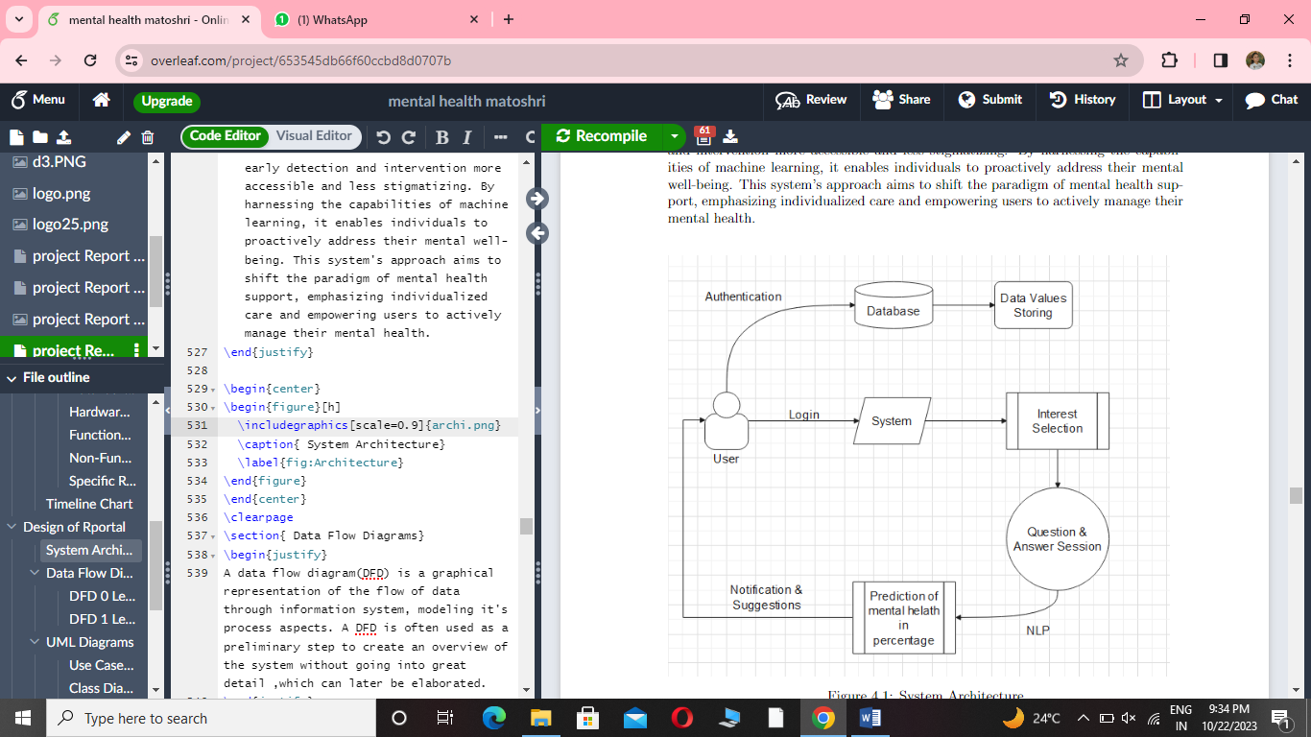

**Fig -1**: System Architecture Diagram

**ADVANTAGES**

* Detecting mental health issues at an early stage allows for timely intervention, leading to better outcomes and preventing the escalation of problems.
* Accurate detection allows healthcare professionals to develop tailored treatment plans, which can be more effective in addressing an individual's specific needs.
* Machine learning can be used for continuous monitoring of mental health. Wearable devices and smartphone apps can collect data over time, providing insights into changes in mental well-being and allowing for timely intervention.

**FUNCTIONAL & NON-FUNCTIONAL REQUIREMENTS**

**Functional requirements:**

* REQ-1: Users should be able to create accounts and provide basic information, including age and gender, to help tailor the assessment and recommendations.
* REQ-2: The system should present a set of multiple-choice questions related to mental health.
* REQ-3: The system should categorize users into three levels: low, medium, and high based on their mental health scores.
* REQ-4: Based on the user's mental health category, the system should provide tailored suggestions and resources to improve their mental well-being.
* REQ-5: Allow users to provide feedback on the assessment and recommendations.

**Nonfunctional Requirements**:

* REQ-1 : The system should be user-friendly and easy to navigate, ensuring that users can comfortably complete the assessment and access recommendations.
* REQ-2 : The system should respond promptly to user interactions, including question loading and categorization calculations.
* REQ-3 : The system should be designed to scale easily to accommodate a growing user base without disruptions.
* REQ-4: User data, including assessment responses and personal information, should be protected through encryption and access control measures.
* REQ-5 : Manage system resources efficiently to control operational costs and reduce the environmental footprint

**SYSTEM REQUIREMENTS**

**Software Used:**

* Vs Code
* Python 3.10
* SQLite Database
* Language: Bootstrap and Python
* Operating System: Windows 8 and above

**Hardware Used:**

* Processor - Processor core i3
* Speed - 1.1 GHZ
* RAM – 4GB
* Hard disk - 500 GB
* Keyboard - Standard Keyboard
* Mouse - Two Or Three Button Mouse
* Monitor - LED Monitor

**CONCLUSION**

In conclusion, the application of machine learning in the field of mental health detection and support holds immense promise. By automating the assessment of individuals’ mental health levels through carefully designed questions and offering personalized recommendations and resources, this technology can contribute significantly to early intervention and improved well-being. However, it is crucial to approach the development and deployment of such systems with great care, ensuring data privacy, ethical considerations, and the incorporation of mental health professionals’ expertise. As we move forward, the synergy between machine learning and mental health care has the potential to revolutionize the way we address mental health issues, offering a proactive and individualized approach to support individuals in their journey towards mental well-being.

**REFERENCES**

[1] Kazi Zawad Arefin, Towards Developing An EMR in Mental Health Care for Children’s Mental Health Development among the Underserved Communities

in USA, 2021 IEEE 45th Annual Computers, Software, and Applications Conference (COMPSAC).

[2] Braden Tabisula, The Need for an Adaptive Sociotechnical Model for Managing Mental Health in a Pandemic, 2022 IEEE International Conference on Digital Health (ICDH)

[3] Jinping Liu, The promotion effect of innovation and entrepreneurship education on medical students’ mental health based on stepwise regression, 2021 International Conference on Public Health and Data Science (ICPHDS

[4] Muhammad Arsyad Subu, Smartphone Addiction and Mental Health Wellbeing Among Indonesian Adolescents, 2023 IEEE 47th Annual Computers, Software, and Applications Conference (COMPSAC)

[5] V.L. Patel, J.F. Arocha and A.W. Kushniruk, ”Patients’ and physicians’ understanding of health and biomedical concepts: relationship to the design of EMR systems”, Journal of biomedical informatics, vol. 35, no. 1, pp. 8-16, 2002.

[6] P.B. Jensen, L.J. Jensen and S. Brunak, ”Mining electronic health records: towards better research applications and clinical care”, Nature Reviews Genetics, vol. 13, no. 6, pp. 395-405, 2012.

[7] R. Hillestad, J. Bigelow, A. Bower, F. Girosi, R. Meili, R. Scoville, et al., ”Can electronic medical record systems transform health care? Potential health benefits savings and costs”, Health affairs, vol. 24, no. 5, pp. 1103-1117, 2005.MCERC 23